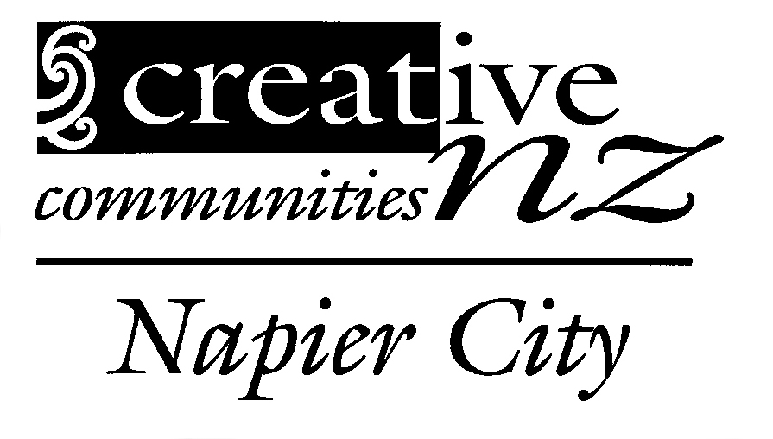

Creative Communities Assessment Committee

Their Role:
Committee members are the heart of the scheme. They assess the applications and allocating the funding, in line with specific local priorities that have been set by council

The committee should collectively have a board knowledge of the arts activity in our local community, and reflect the make-up of the community.

Who sits on the committee
The committee consists of two councillors (appointed by the Mayor) and community representatives (usually about seven – nine members).

Term
Committee members are appointed for a term of up to three years and can serve a maximum of two consecutive terms.

Funding Rounds
There are two funding rounds per annum in March and September.

