Together Fund

Information sheet and guidelines
Well-connected neighbourhoods make safe, dynamic and vibrant communities. This fund encourages groups of people to get together to work on new projects that improve connectedness within communities and contribute to the amenity of Napier as a whole.

What is a neighbourhood?
For the purposes of this fund, a ‘neighbourhood’ is linked to a place. Neighbourhoods will typically be residents of a particular street but can include a ‘natural’ neighbourhood such as the users of a particular park or playground. A ‘natural’ neighbourhood might also be a configuration of houses such as a block or houses that overlook a park.

What is a community?
In the case of this fund, a community is either a collection of neighbourhoods (e.g. a suburb) or a community of interest. A community of interest is a group of people who share a common interest rather than a common place.
This fund is administered in partnership with Napier Neighbourhood Support.

Funding Priorities
Priority is given to projects that provide an opportunity for people to work together to:
- Support, develop or celebrate a neighbourhood’s or community’s uniqueness or identity, and/or
- Encourage new or expanded connections within a neighbourhood, and/or
- Improve the physical or recreational value within a neighbourhood or community, and/or
- Respond to a particular issue within a community or neighbourhood, and/or
- Improve the safety of a neighbourhood or community
- Provide intergenerational opportunities

Funding Limits
You can apply for minimum of $100 and a maximum of $5000.

GST
All grant payments will be paid on a GST inclusive basis. If your group is GST registered, then your funding request must exclude GST. If your group is not GST registered, the funding request must include GST.

Who can apply?
Applications are accepted from groups within Napier neighbourhoods and communities – these groups can be ‘informal’ e.g. a neighbourhood support group, a collection of neighbours, a group of park users etc.
Family trusts, social clubs, chartered clubs or individual family/whanau groups are not eligible for funding. Applications will be considered from hapu and iwi.
Projects must be inclusive, for example invitations to a Street BBQ must go to all residents in the street.

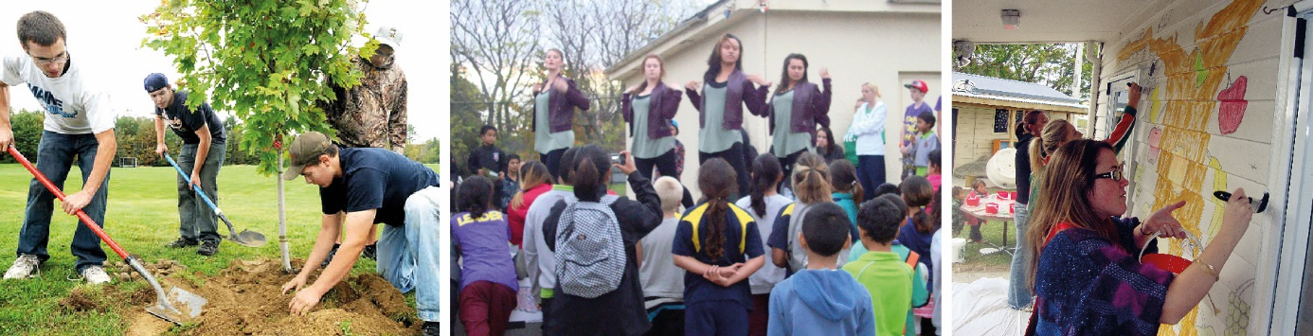

How to apply?
By Post | Community Services Team  Napier City Council  Private Bag 6010  Napier 4142
By Courier or by hand | Community Services Team  Napier City Council  Main Reception Desk  Dunvegan House  215 Hastings Street
Email | csgrants@napier.govt.nz
Please Note: Incomplete or late applications will not be considered.

What can be funded?
- Equipment (hire or purchase)
- Plants
- Food
- Materials and resources
- Volunteer costs

What will not be funded?
- Applications under $100
- Applications over $5000
- Expenditure already incurred
- Existing projects and/or regular events
- Reunions
- Fundraising events, projects or campaigns
- Alcohol
- Building maintenance
- Deposit, loan or debt repayments
- Bank or lawyers fees
- Organisatonal operating costs (such as power, rent, telephone costs)
- Wages or salaries
- Project manager/coordinator fees

Projects
Types of projects considered include:
- Kaitiaki / guardianship activities or beautification projects e.g. street working bee, stream clean-up, plantings
- Community or neighbourhood events
- Neighbourhood ‘get togethers’ (particularly those that occur on or around Neighbours Day Aotearoa) e.g. Street BBQ, fun day etc.
- Art installations reflecting neighbourhood/community identity e.g. Signage, murals, sculpture etc)
- Added value projects – e.g. additional play equipment to neighbourhood playground, events that utilise existing community facilities, parks, reserves etc.
- Safety awareness campaigns, particularly through neighbourhood support groups

Decisions
A panel will make the funding decisions. All decisions are final and are not subject to review.

Reporting
If you receive a grant, you will need to tell us how your project went. You will receive a report back form with your grant letter.

