Napier Positive Ageing
Strategy

2020 to 2024

Te Rautaki Tipu Ora o Ahuriri
Before you start

This is a long document.

While it is written in Easy Read it can be hard for some people to read a document this long.

Some things you can do to make it easier are:
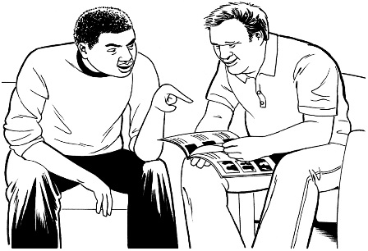
- read it a few pages at a time

- have someone help you to understand it.

What you will find in here?

Page number:

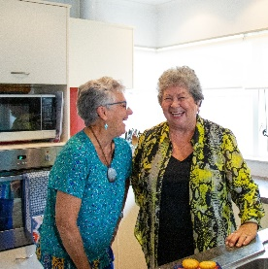

What is an ageing population?.............5

Older people in Napier…………………6

What is the Napier Positive

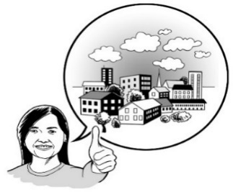
Ageing Strategy?................................10

Our vision………………………………14

Core principles…………….………..…15

Page number:

Priority areas…………………………..18

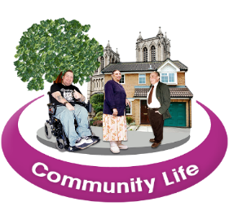
Priority Area 1: Te waitua hapori – Community spirit …..20

Priority Area 2: Kia mōhi, kia mahi – Being Informed and Involved. …..22

Priority Area 3: Kia haumaru – Being safe..…………………………….23

Priority Area 4: Hāereere – Getting around………………………...24

Page number:
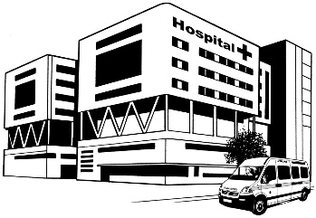

Priority Area 5: Hauora and oranga - Health and wellbeing…………………25

Priority Area 6: Ngā whare – Housing………………………………...27

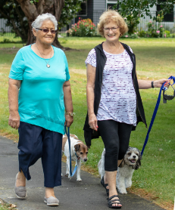

Priority Area 7: Hei mahi – Things to do.…………………………...29

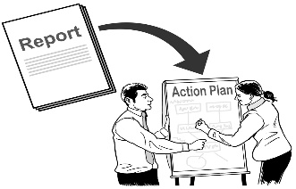
Strategy

Making things happen……………..….30

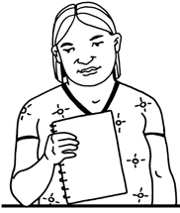
Where to find more information about the Napier Positive Aging Strategy….……………………………..33

What is an ageing population?

Napier is a city in the North Island of New Zealand.

Napier has an ageing population.
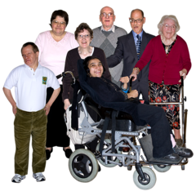

Ageing population means there are more older people living in our community.

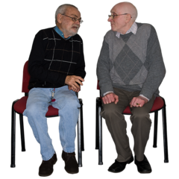
In this strategy when we say older people or older persons we mean people over 65 years old.

Older people in Napier

This strategy understands that our older persons community is a diverse community.

A diverse community is a community that is made up of people from different:
- countries
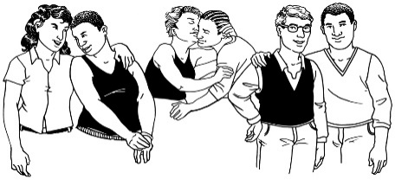
- ethnicities

- sexualities
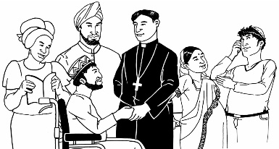
- religions.

We also understand that people in our older persons community have a lot of different needs.

20 percent of people in Napier are older people.

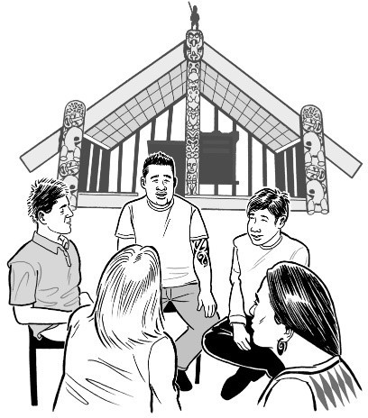
20 percent means about 12 thousand older people live in Napier.

550 older people are Māori.

About half of our older people live in Taradale or Greenmeadows.

By the year 2040 we think there will be almost 20 thousand older people living in Napier.
2040

That means about 1 quarter of people living in Napier will be older people.

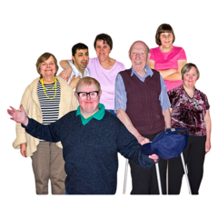
For the first time ever there will be more older people than children in Napier.

This is because people are living longer than they have in the past.

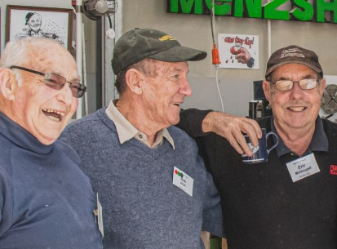
Older people are more likely to keep working after they turn 65 years old.

About 20 percent of our older people are still working.

Some hard things that our older people have to deal with are:

- not having a lot of money after they stop working
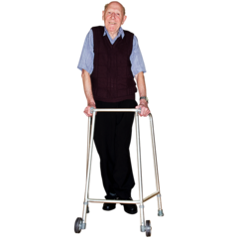
- health issues like disabilities

- being by themselves a lot

- people thinking badly about them being old.

What is the Napier Positive Ageing Strategy?

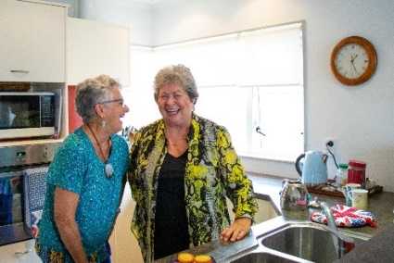
The Napier Positive Ageing Strategy is a plan about how to make things better for older people living in Napier.

It is a 4 year plan that will start in 2020 and end in 2024.

When making this strategy the Napier City Council and others looked at local information.

The Napier City Council also asked 3 groups of people before making this plan:

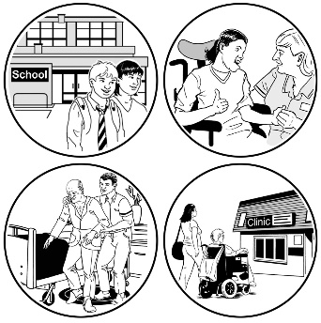
- Different agencies

We asked different agencies that focus on older people in Napier.

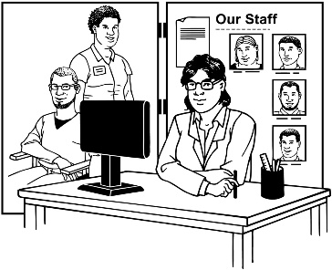
- Service providers

We asked different services that support older people in Napier.

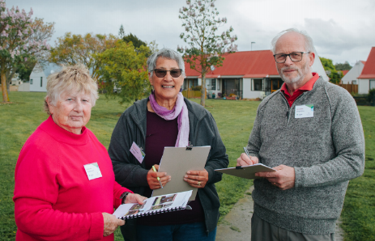
- Older people in the Napier community.

The Napier Positive Ageing Strategy is made up of:

- 1 vision

- 7 priority areas

- 6 principles.

A vision is the goal Napier City is working towards.

Priority areas are the things we are going to focus on.

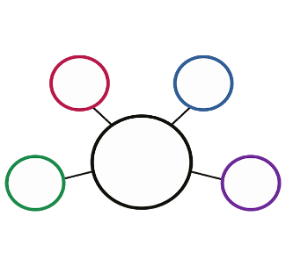

The principles are the values we are going to make sure we follow.

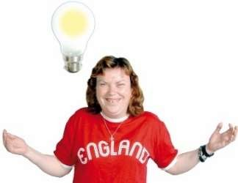
Values are ideas that we have about the things that are important to our way of life.

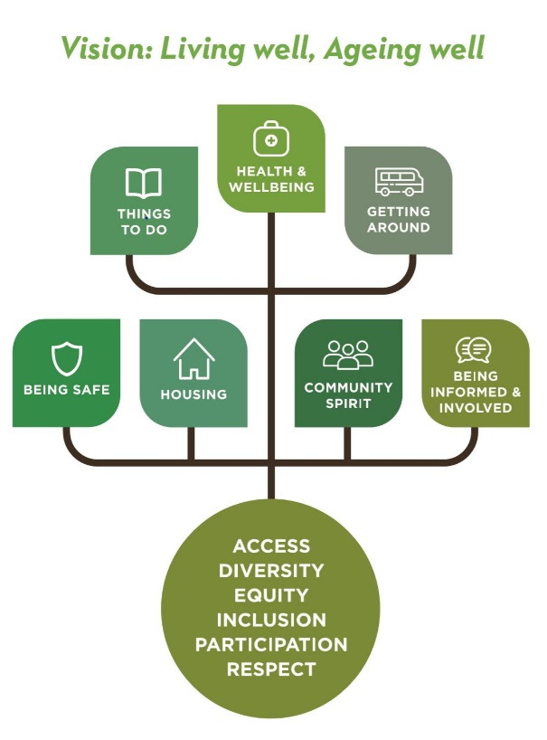
All of these are shown on this tree.

We used a tree because the:

- vision is like a tree

- 7 priority areas are like leaves that grow

- principles are like roots that hold us together.

Our vision

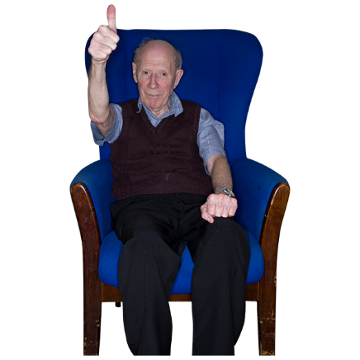
The vision of the Napier Positive Aging Strategy is:

- living well

- ageing well.

This vision is about everyone in Napier understanding that we all:

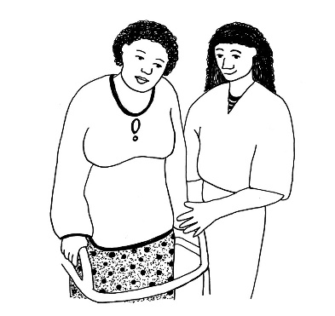
- will get old

- need support when we get old.

Principles

The 6 principles of this strategy are:

- Āheitanga - access
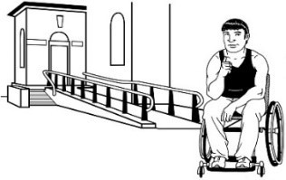
Having access means being able to:

- go to places that are easy for older people to get to and use

- get information that is easy for older people to get and use.

- Rerenga kētanga – diversity

See page 6 to see what diversity means.
- Mana taurite – equity

Equity means that everyone gets what they need.

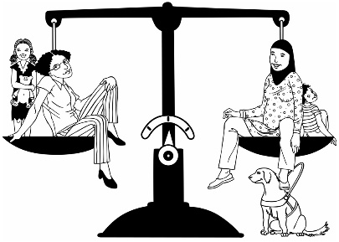
This is different from equality.

Equality means everyone gets the same things.

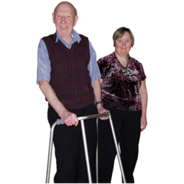
- Whakawhāititanga – inclusion

Inclusion means everyone in our community is:
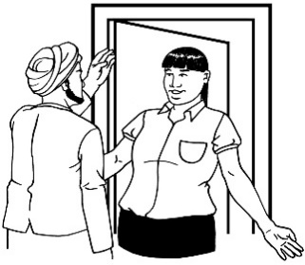
- valued

- welcome.
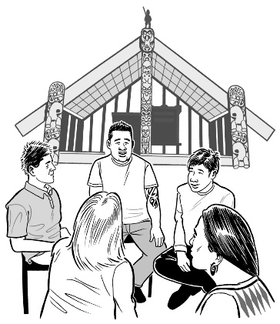
- Whai wāhitanga – participation

Participation means being a part of community life.

- Kauanuanu – respect

Respect means treating everyone well even if you do not agree with them.

Priority areas

This strategy has 7 priority areas.

Priority areas are the things we are going to focus on.

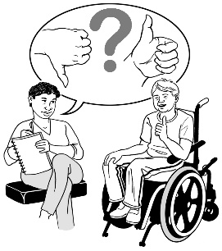
We picked these 7 areas after:

- talking with our community

- looking over important information.

Each priority area will have things that we want to do.

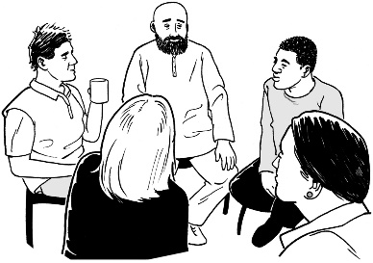
Each priority area will be looked after by different organisations.

Napier City Council will look after how these organisations work on the strategy.

The order we put the priority areas in does not mean that priority 1 is more important than the others.

All the priority areas have the same importance.

Priority Area 1: Te wairua hapori –
Community spirit

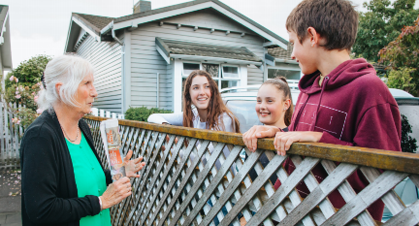
We want our older people to feel:

- like they belong in Napier
- valued by the community

- that their problems are being taken seriously.

We also want our older people to keep connected with their:

- whānau / family
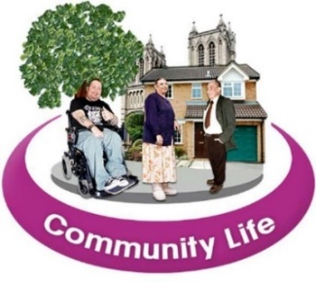
- friends

- community.
The organisation that will work on this priority area is the Positive Ageing Strategy Advisory Group.

Priority Area 2: Kia mōhio, kia mahi –
Being informed and involved

We want older people to live happily in our community.

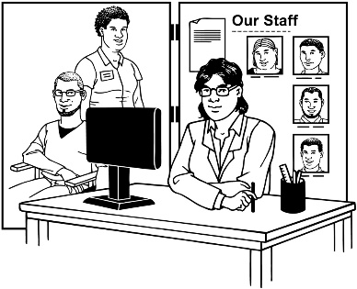
We will make sure they feel ready by giving them information about services that support older people.

The organisation that will work on this priority area is Age Concern Napier.

Priority Area 3: Kia haumaru –

Being safe

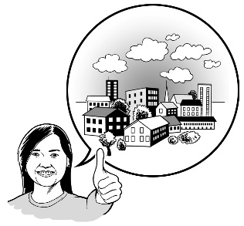
We want to make sure everyone feels safe to grow old in our:

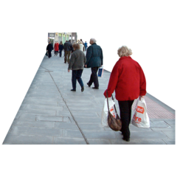
- city

- neighbourhoods

- community.

The organisation that will work on this priority area is Safer Napier Strategic Group.

Priority Area 4: Hāereere – Getting around

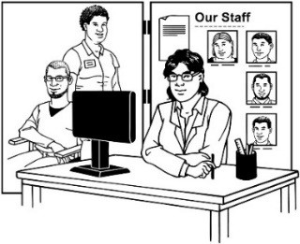
We will make sure people can easily use:

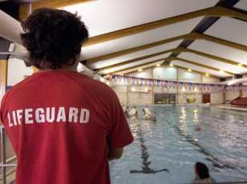
- services

- the places in our community.

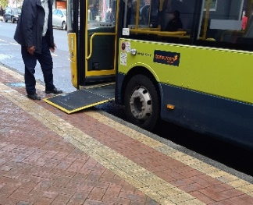
To do this we will make sure they:

- have accessible transport

- are easy to get to

- do not cost a lot of money.

The organisation that will work on this priority area is Hawke’s Bay Regional Council.

Priority Area 5: Hauora and oranga –
Health and wellbeing

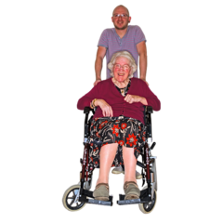
We will make sure older people have affordable:

- health care services

- support services.

When something is affordable it means you have enough money to pay for it.

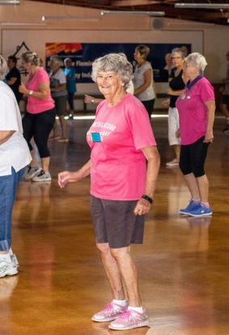
We want to support our older people to stay:

- healthy

- active:

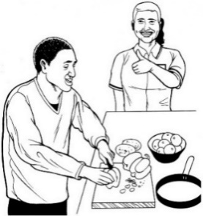
  - being able to do some exercise

  - keeping busy

- in charge of their own lives.

The organisation that will work on this priority area is Hawke’s Bay District Health Board.

Priority Area 6: Ngā whare – Housing

We want people to be able to pick between good housing options.

Housing options means places people can live like:
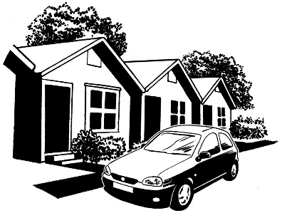
- houses

- units

- villages.

We want to make sure housing options are:

- affordable

- accessible.
We want people to feel:

- safe

- warm
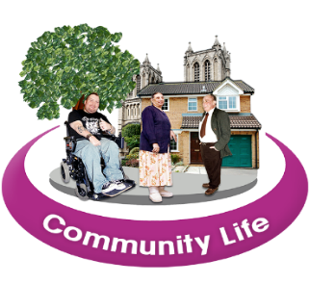
- healthy

- part of our community.

The organisation that will work on this priority area is Napier City Council.

Priority Area 7: Hei mahi – Things to do

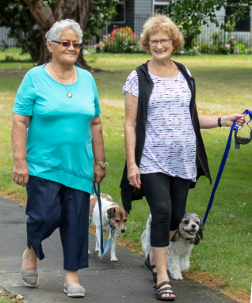
We want people to feel valued in our community.

We want people to enjoy living in Napier.

To do this we will make sure there are places people can go that are:

- accessible

- affordable.

Some places older people can go to are:

- places that do not cost a lot of money to go to and use

- spaces for people to have fun and relax like

  - leisure spaces
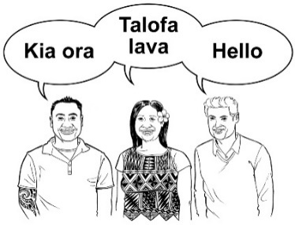
  - recreation centres

- cultural activities.

Making things happen

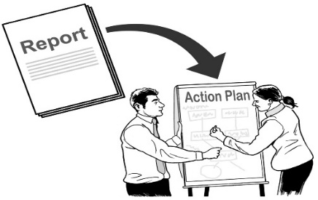
Strategy

A plan will be made on how to make Napier a good place to grow old.

The plan will be made by a Positive Ageing Strategy Advisory Group.

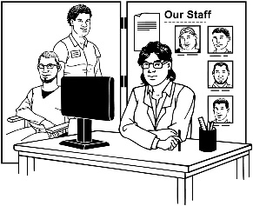
The Advisory Group will have people from:

- organisations look after the priority areas

- services that provide support to older people

- the older persons community.

The Advisory Group will:

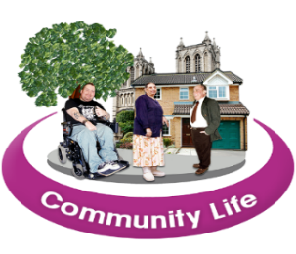
- help to choose which actions to do first

- do the actions in the community spirit priority area
- keep track of how well the plan is working.

The Advisory Group will be supported by Napier City Council.

Where to find more information about the Napier Positive Aging Strategy

You can get more information about the Positive Aging Strategy from the Napier City Council.

Website: www.napier.govt.nz

Email: info@napier.govt.nz

Phone: 06 835 7579

Facebook: Napier City Council

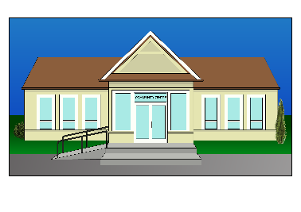
www.facebook.com/NapierCityCouncil

Office: 215 Hastings Street
Napier
This information has been translated into Easy Read by the Make It Easy service of People First New Zealand Inc. Ngā Tāngata Tuatahi.
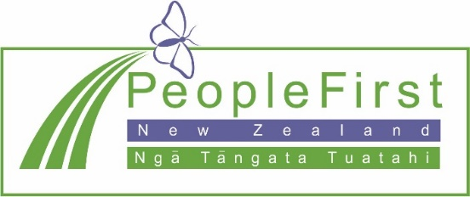
The ideas in this document are not the ideas of People First New Zealand Ngā Tāngata Tuatahi.

Make It Easy uses images from:

- Changepeople.org

- Photosymbols.com

- Sam Corliss

- Steve Bolton

All images used in this Easy Read document are subject to copyright rules and cannot be used without permission.

