The Tech Collective - What It Means for the Napier Economy

The technology sector is already emerging as a future powerhouse of the New Zealand economy.

New Zealand's technology sector has become the country's third biggest export sector as the top 200 companies burst through $10 billion in sales in the year to October 2017. The Technology Investment Network (TIN) said overseas earnings last year were $7 billion, with only tourism and dairy earning more.

"We've seen a sustained increase of around 8 percent in both revenue growth and exports, but more significantly, the real story is in the integral part that the technology sector now plays in the country's economy," TIN managing director Greg Shanahan said.

Key gains in New Zealand have been made in biotechnology, high tech manufacturing and information and communication technology. There are now over 43,000 Kiwis employed in the tech sector, with 4,300 new jobs added over 2017.

The technology sector has several advantages for economic development – it drives innovation, it develops the skills base of regions, and it pays high salaries relative to more traditional sectors such as horticulture and tourism.

The New Zealand Government is fully aware of the potential of the tech sector. Agencies such as the Ministry of Business, Innovation and Employment (MBIE) and Callaghan Innovation are supporting technology based businesses and industries across New Zealand to ensure that the nation reaches its economic potential in these sectors.

Victoria Crone, chief executive of Callaghan Innovation, said recently that technology was a key for growth in New Zealand’s economy. “Every dollar invested in the tech sector creates three dollars of growth in the New Zealand economy. Doubling or tripling the contribution of dairy or tourism by simply expanding these sectors is simply not practical given their respective demands on land, water and infrastructure.

“By contrast all the tech sector needs to expand is more brains, more ideas and more capital to bring them to market.”

Key points of interest from a recent MBIE report on the ICT sector include:

- Continued growth in jobs in the sector, with more vacancies than any other sector in the economy;
- Strong growth in firm numbers, with an encouraging increase in large (100+ employee) firms;
- Highly innovative, with the sector driving growth in New Zealand business expenditure on R&D;
- An increase in New Zealand firms growing through offshore acquisition;
- Case studies of New Zealand firms using and developing cutting-edge technology.

Napier is emerging as a potentially key node in New Zealand’s technology sector. The city and the Hawke’s Bay region have excellent advantages in the traditional economy – the airport, the port, good roading infrastructure and a great lifestyle that appeals to companies and households. In addition, the region also has great technology infrastructure, with fast, reliable and affordable broadband, an excellent ICT school at the Eastern Institute of Technology (EIT), and an emerging start-up scene in the tech sector. Since one of the main growth constraints on the sector is the shortage of high tech skills, Hawke’s Bay will need to up its game in the nurturing of technology talent.

A recent study of Hawke’s Bay industry growth sectors undertaken by EIT and commissioned by Business Hawke’s Bay and MBIE that the technology sector is one of the strongest local industry sectors that is projecting growth in entrepreneurship and investment opportunities.

Newly arrived companies such as Xero and Fingermark are making their mark and employing young and not so young Hawke’s Bay residents to drive this new growth. They are also bringing new skills to the region, as they often need to fill their positions from outside Hawke’s Bay.

The digital economy is a critical component of Hawke’s Bay’s Regional Economic Development Strategy (Matariki REDS). The goal is to create a safe, smart and connected region and to be a “digital corridor” for our residents, businesses and visitors.

The Hawke’s Bay councils have recently collaborated to complete district and regional Digital Enablement Plans as part of the response to the Government’s stage two broadband initiatives, and as part of the development of the Region’s Economic Development Strategy. Napier City Council is leading the work in developing a “Connected Hawke’s Bay” plan that focuses on:

- Affordable access to the best digital infrastructure available;
- The enhancement of community and business digital capability across all sectors; and
- The development of a strong technology sector.

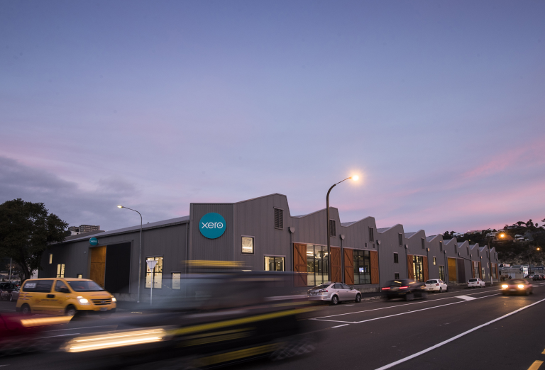

The Wallace Development Corporation has taken the lead in developing its Tech Collective, with an initial development at Ahuriri. The TC combines a co-working space for entrepreneurs and start-ups with funky accommodation for anchor technology tenants who have strong plans for future expansion. Places like the Tech Collective are the workspaces of the future, as more and more people, especially young people, opt for participating in the “gig economy”.

The Tech Collective’s companies include the following:

- NOW;
- Xero;
- DataNow;
- Re-leased;
- Grundy Productions;
- Web Fox;
- Many Hats.

These are outstanding local companies that will continue to drive economic development in Napier and Hawke’s Bay. Napier City Council is proud to have these companies choosing to locate in our city. Two case studies on Tech Collective companies can be found below.

What Xero is saying:

We started Xero to change the game for small business. Our beautiful cloud-based accounting software connects people with the right numbers anytime, anywhere, on any device. For accountants and bookkeepers, Xero helps build a trusted relationship with small business clients through online collaboration. We’re proud to be helping over 1 million subscribers worldwide transform the way they do business. And we’re just getting started.

What NOW is saying:

Awesome isn’t just our tagline, it’s our promise to you.

We take service seriously. That’s why we have local sales and service hubs close to our customers – we can be on your doorstep in a flash to sort things out.

It’s also why we established the Digital Concierge because we know that sometimes you want more than just a helpdesk. Whether it’s the Wi-Fi dropping out or your iPad won’t connect, with our Digital Concierge, it’s sorted!

It doesn't matter if you are seeking services for home or at work, in Hawke's Bay, Wellington or Rotorua, we are your best choice!

More information on the Tech Collective and its companies can be found at:
https://www.techcollective.co.nz/location/hawkes-bay

In summary, the technology sector’s growth is both an opportunity and a challenge for Napier, for Hawke’s bay and for New Zealand as a whole. The sector itself is growing rapidly, technologies are disrupting key traditional sectors and occupations, and the nature of work and of working spaces is changing dramatically. Napier is attracting new firms and new talent, on the back of its outstanding lifestyle and infrastructure. We need to ride the wave that is gathering force, to ensure that our young people, in particular, are aware of the emerging opportunities and that they position themselves to embrace the new economy. Companies like Wallace Development have seen the future and are getting on with the task of creating the 21st century tech infrastructure that the region needs.

