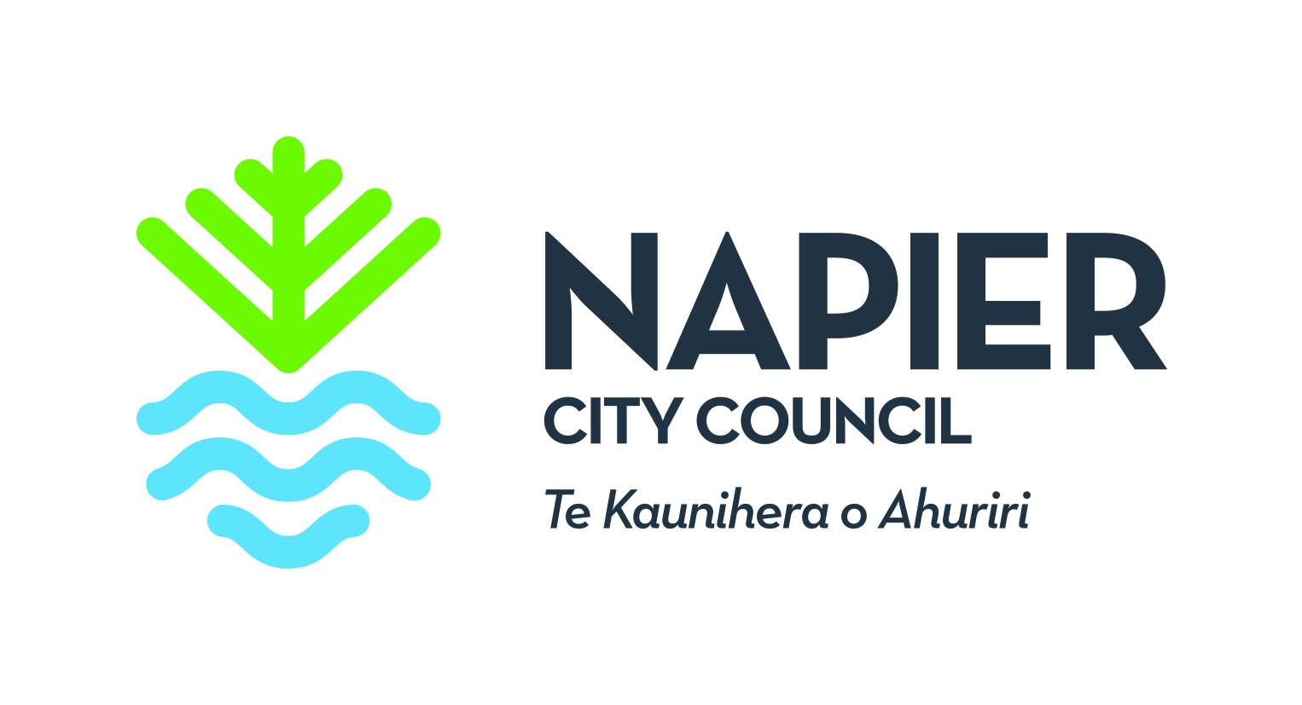
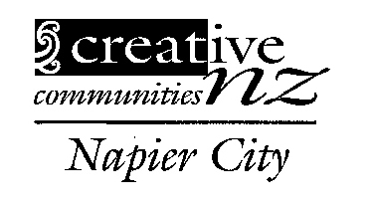
Napier Creative Communities Scheme
Committee Assessor Nomination Form
The Napier Creative Communities Scheme (CCS) assessment committee allocates CCS funding on behalf of CNZ, for Napier City. The committee is made up of councillors and community representatives who are familiar with a broad range of local arts activities. They assess the applications for funding, and can sit on the committee for a maximum of two, three year terms.
We are seeking a representative that works with young people, or are connected to arts loving youth.

Name of nominee:

Address:
Email:
Phone:
Please mark the artforms that you have expertise in with an X:
 | Craft/object art |  |  |  | Dance |  | Inter-arts
 | Literature |  |  |  | Music |  | Ngā toi Māori
 | Pacific arts |  |  |  | Multi-artform (including film) |  | Theatre
 | Visual arts
What other skills or knowledge would you bring to the assessment committee? e.g. assessment skills, knowledge of a particular community, skills in working with youth in the arts sector etc? Please attached reference letters.

Name of person making nomination:

Email:
Phone:
Date:

Please return your nomination form to the Community Funding Advisor belindam@napier.govt.nz
Closes 5.00 pm Friday 2 November 2018 (no late applications will be accepted)

